**STUDENT REGISTRATION FORM WITH FRONTEND AND BACKEND**

**A Project Report submitted in partial fulfillment of the requirements for the award of the degree of**

**BACHELOR OF TECHNOLOGY IN**

**COMPUTER SCIENCE AND ENGINEERING**

**Submitted by**

## **KADIYALA P B ROHIT BHARADWAJ, 121910313006**

## **A CHAKRAPANI, 121910313015**

## **B SHANMUKHA SAI, 121910313020**

**Under the esteemed guidance of**

**Dr D.Soujanya**

**Assistant Professor**



**DEPARTMENT OF COMPUTER SCIENCE & ENGINEERING GITAM**

**(Deemed to be University)**

**VISAKHAPATNAM**

**OCTOBER 2022**

# 

# **DEPARTMENT OF COMPUTER SCIENCE AND ENGINEERING GITAM SCHOOL OF TECHNOLOGY**

**GITAM**

**(Deemed to be University)**

# 

# **DECLARATION**

I/We, hereby declare that the project report entitled **“**STUDENT REGISTRATION FORM WITH FRONTEND AND BACKEND” is an original work done in the Department of Computer Science and Engineering, GITAM School of Technology, GITAM (Deemed to be University) submitted in partial fulfillment of the requirements for the award of the degree of B.Tech. in Computer Science and Engineering. The work has not been submitted to any other college or University for the award of any degree or diploma.

Date:

**Registration No(s). Name(s) Signature(s)**

121910313006 K P B ROHIT BHARADWAJ 

121910313015 A CHAKRAPANI 

121910313020 B SHANMUKA SAI 

# **DEPARTMENT OF COMPUTER SCIENCE AND ENGINEERING GITAM SCHOOL OF TECHNOLOGY**

**GITAM**

**(Deemed to be University)**



# **CERTIFICATE**

This is to certify that the project report entitled “STUDENT REGISTRATION FORM WITH FRONTEND AND BACKEND” is a bonafide record of work carried out by **KADIYALA P B ROHIT BHARADWAJ (121910313006), A CHAKRAPANI (121910313015), B SHANMUKHA SAI (121910313020)** students submitted in partial fulfillment of requirement for the award of degree of Bachelors of Technology in Computer Science and Engineering.

|  |  |
| --- | --- |
| **Project Guide** | **Head of the Department** |
| **Dr D.Soujanya**  **Assistant Professor** | **Dr.R.Sireesha**  **Professor** |
|  |  |

**TABLE OF CONTENTS**

**Page No**

1. Abstract 5
2. Introduction 5
3. Problem Identification 5-6
4. System Methodology 6
5. Overview of Technologies 6-11
6. Implementation 11-21
7. Results and Discussion 22-29
8. Conclusion & Future Scope 30

# **Abstract**

In this rapidly changing world most MNC’s and other technological firms are collecting user’s data through these registrations forms. The structure will be same but the information collected will vary to vary. Record keeping is main reason for using these registration forms. Some of the companies use these forms for recruiting freshers for job offering so that they can know in what expertise they are good at. University and Colleges also use these forms for course registration or exam registration. So in our project we built a Student Registration Form by using Tkinter as Frontend and SQLite as Backend for Database and also we create a small website for this form using web development technologies such as HTML, CSS, and JS etc.

**Introduction**

A Registration form is a list of fields that users enter data into and submit to a company or individual. There are many reasons why you might want someone to fill out a registration form. Businesses use sign-up forms to register customers for subscriptions, services, or other programs or plans. A Registration form contains two main components they are Frontend and Backend. Frontend acts as a user interface for filling out forms and Backend acts as storage for collecting the filled out data from the UI.

**Problem** **Identification**

In general, we need some data to get some results. The information might be in any format. It may differ from one person to the next or even from one company to the next. Customer or student data can be found and collected in one of the data forms such as registration forms. It enables us to learn a lot more about the end-user. We used to collect various forms of data on paper, such as applications, but as technology advances, the data is now collected in digital form. So, in our project, we built a simple registration form to learn about the underlying process of data collection and storage. We constructed the registration form frontend using Tkinter, and we also created the identical form for the website using HTML, CSS, and JS.For our backend that is for storing the form data we SQLite database browser engine application for pushing the details from the form to the database. We can also access this database to update or delete the data entered also.

**System Methodology**

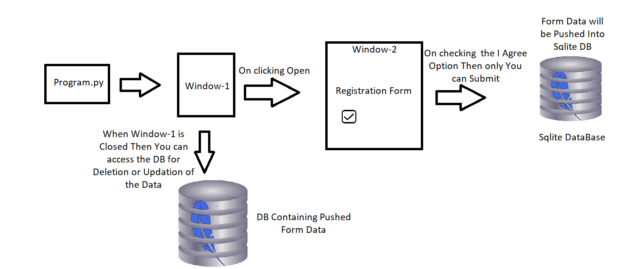

Fig: Program Flow Chart

**Overview of Technologies Used In Our Project**

**Tkinter**

Tkinter is a Python binding for the Tk GUI toolkit. It is the official Python interface to the Tk GUI toolkit and Python's de facto standard GUI. Tkinter is included in standard Python installations on Linux, Microsoft Windows, and macOS. The word Tkinter is derived from the Tk interface. Tkinter was written by Steen Lumholt and Guido van Rossum, and then later revised by Fredrik Lundh.

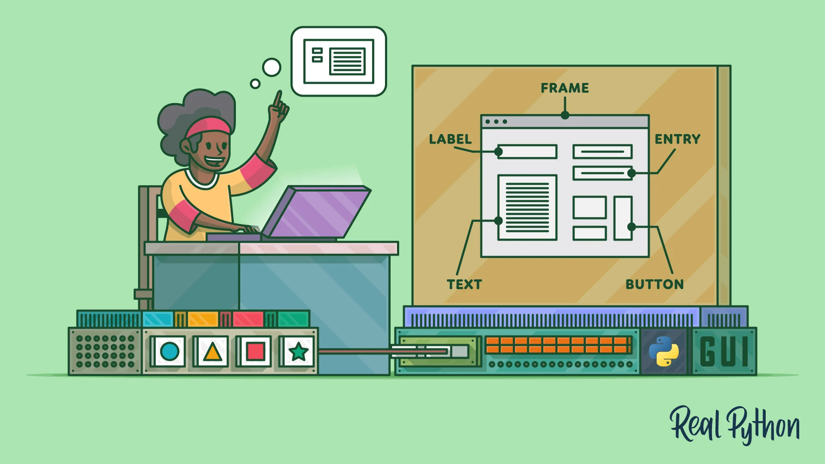

It is simple to create a GUI application with Tkinter. All you have to do is follow the steps below.

* Import the *Tkinter* module.
* Create the GUI application main window.
* Add one or more of the widgets listed above to the GUI programme.
* Enter the main event loop to take action against each event triggered by the user.

**Tkinter Widgets:**

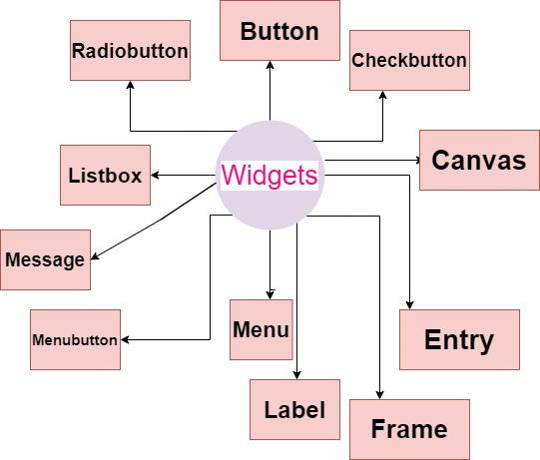



**Pycharm**

PyCharm is a Python-specific Integrated Development Environment (IDE) that provides a wide range of necessary tools for Python developers. These tools are tightly integrated to create a pleasant environment for productive Python, web, and data science development. It was developed by Jet Brains software Development Company.

PyCharm displays your plots within the IDE and keeps track of the most recent plots you've made to make it easier to detect differences between two plots.

Pycharm gives you a convenient way to install, uninstall and upgrade your packages whenever you want. It will automatically adjusts the packages right away after the installation. It will be great IDE for ML and Data science Project. We use this IDE to implement our code and run our tkinter and database file in a much more convenient way



**Sqlite3**

The Python SQLite3 module is used to integrate SQLite databases with Python. This is the standardized Python DBI API 2.0, providing a simple and easy-to-use interface for interacting with SQLite databases.

SQLite's package includes a standalone command-line shell tool called sqlite3. It is capable of creating a database, defining tables, inserting and changing rows, running queries, and managing a SQLite database file. It also serves as a model for developing SQLite-based applications.

We used Sqlite3 package by importing in pycharm IDE to connect with our database file so that we can insert, update and delete the data which is entered from the Tkinter Registration Form.

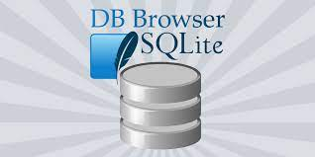

**DB Browser For SQLite**

DB Browser for SQLite (DB4S) is a high-quality, visual, open source tool for creating, designing, and editing SQLite database files.

DB4S is a database management system for users and developers that want to create, search, and change databases. DB4S has a familiar spreadsheet-like interface, and complex SQL instructions are not required.

We used this tool which is very convenient to use in our project as a database for storing the data. It is portable SQLite application which can be easily integrated with python environment.

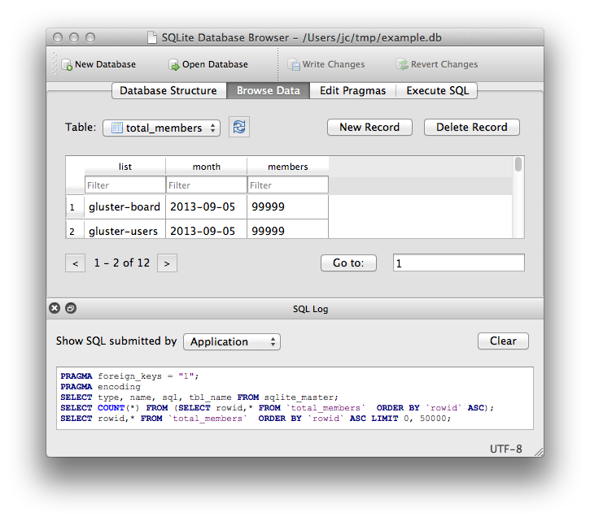

**HTML**

The preferred markup language for documents intended to be viewed in a web browser is HTML, often known as Hypertext Markup Language. It can benefit from tools like CSS and programming languages like JavaScript.

The markup language HTML5 is used to organize and present content on the Internet. It is a World Wide Web Consortium (W3C) guideline and the fifth and last major HTML version. The HTML Living Standard is the name of the most recent specification. The Web Hypertext Application Technology Working Group (WHATWG), an association of the principal browser manufacturers, looks after it (Apple, Google, Mozilla, and Microsoft)



**CSS**

Cascading Style Sheets (CSS) is a style sheet language used to describe the display of a document produced in a markup language, such as HTML or XML. Along with HTML and JavaScript, CSS is a fundamental component of the World Wide Web.

**JAVASCRIPT**

Along with HTML and CSS, the computer language known as JavaScript, or JS, is one of the foundational elements of the World Wide Web. JavaScript to program the behavior of web pages.

Making interactive web pages is possible with JavaScript, a text-based computer language used both on the client-side and server-side. JavaScript adds interactive aspects to online pages that keep users interested, whereas HTML and CSS are languages that give web pages structure and style.

# **Implementation**

# **Coding**

# **Tkinter and SQLite Code**

|  |
| --- |
|  |

# **SQLite Interface**

|  |
| --- |
|  |

# 

# **HTML**

|  |
| --- |
|  |

# **CSS & JS Code**

|  |
| --- |
|  |

# **Results & Discussions**

# **Output**

# **Tkinter and SQLite**

|  |
| --- |
| Updating a Record in the Database    ID Column is Updated from 121910313006 to 100     HTML & CSS   Alert Box will Display the instructions If Name field is left Empty |

|  |
| --- |
| Name Field Only takes Alphabets    The data was recorded in sql database when the user confirm login |

# **Conclusion & Future Scope**

As a result, this project clearly displays the operation of data gathering via registration forms. It features both a frontend and a backend for collecting user information and storing it in databases. With the aid of AI and ML technical developments, this entire procedure will be completely automated in the future. We can provide services such as automated data collecting based on previously filled data on different websites, cloud access for regularly accessed or logged in websites, and so on. Instead of employing a database application, there may be an opportunity to use virtual cloud databases, which automatically improve data storage and retrieval from forms for users. It will be an efficient method of collecting user data. New technologies will be introduced, and new features will be added to make the registration forms more compatible and adaptable to use.